SGBS Customer Order Entry

Menu Option
Harris Main Menu 10 Order Management
Order Management 6 Order Processing
Order Processing 1 Order Entry

Use Order Type “B” which will set the flag to create the MO for Kit/Apply for this order.

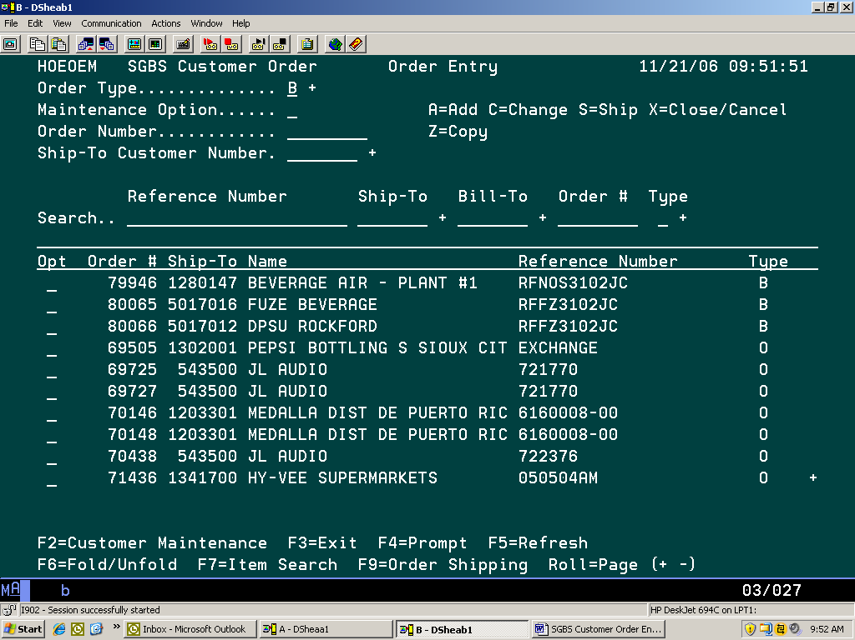

Enter the Ship to customer number.

SGBS Customer Order Entry

Enter the Customer’s P.O. in the Reference Number

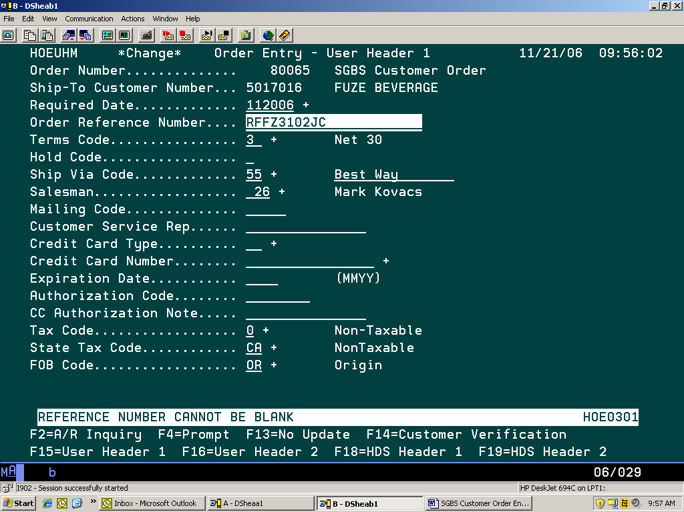

SGBS Customer Order Entry

When ever an item is entered and the price is all “8’s” or “9’s”, a price or “0.00’ must be entered as an override. If the “8’s” or “9’s” are left on the order it will cause problems processing the order.

